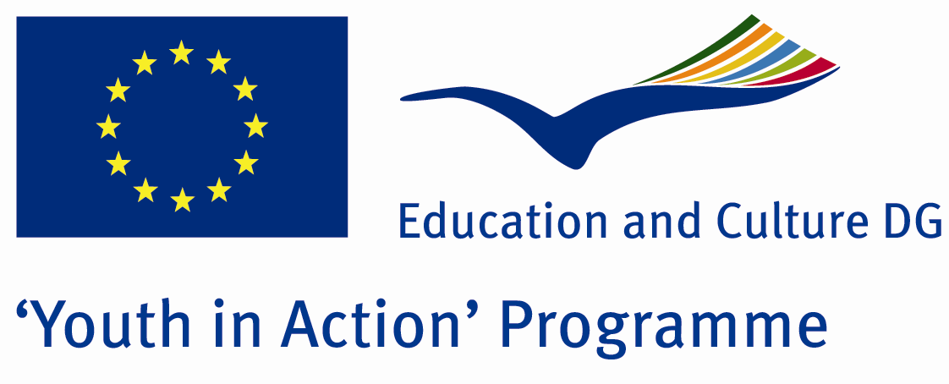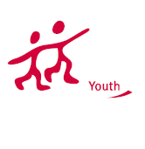

Action 1.1
Project Summary; Some people said they are gipsy... Some people said they are thieves. Ones said they are bad people… We claim that most of them are so kind and friendly people. Yes, i mean that Romens people… Do you know how difficult is to be Romen in this world. You have been lived in a country for years… But you can’t feel you belong to this country… Because the other people doesn’t allow this… In all the world, most of the people see you as witch… But the worst thing is not your fault… Just only You were born from Romen mother… And you didn’t choose her… And moreover she is the best mother for you… But some people think that you are second class person because of only your relatives, your father, mother or family…
To sum up, in this Project we learn romen’s culture, lives and musical skills. Because most of them are true-born musicians… It is the miracle of God. At the end of the Project, the participants will learn it is so bad that to evaluate people as the bad people without knowing anything about them. For this aim, for learning their culture, dances, music, for fun and to be friend from the other countries, participate us.

Project Title; The Story of Colourful Life
Date and Venue ; 19-26 2013 February Turkey
Place: Edirne.

Target Group ; Municipalities, City Councils and Non-Governmental organizations,
youth groups,culture and art groups,e.t.c

Participants ; 5 people from each country (over 18 -25 ). Totally 7 countries.

Conditions ; Accommodation, board and programme costs will be financed through European Commission Youth in Action Programme . Travel costs will be reimbursed in 70% (APEX Tarrifs). Organizations from all 27 EU member countries plus Liechtenstein , Norway and Iceland are eligible to take part.

Working language: English

Organisator group: Group Sınır

How to apply: If you are interested, please send your Part III forms to
by e-mail please (in word file). Scan Part3 format is enough for application.(Fulfilled Part III which you can find in the attachment, of course signed and stamped) ..

Contact e-mail: groupsymrnes@gmail.com
Group e-mail: groupsinir@gmail.com

Deadline to apply:20.09.2012

